Towards an Ontology-based Iconography

Abstract
This article describes work undertaken at the Warburg Institute in London into the definition of machine-readable ontologies for the identification of iconographic subjects. Iconography, a descriptive discipline concerned with the identification of the content or subject of an image, is a core component of the wider discipline of iconology, the study of the meanings of images in their cultural or historical contexts. The research detailed here attempts to define the core of an ontology for the indicators of an iconographic subject that would be employed by an art historian in making an identification: these are encoded in OWL, the Web Ontology Language. The article demonstrates how such an ontology may be queried in XML format using simple XQUERY queries. Future directions for this research are discussed, including its possible integration with image recognition technologies to facilitate more automated approaches to iconographic identification.

Introduction

Iconology is an academic discipline which concerns itself with the meanings of images, particularly in relation to their cultural or historical contexts. A core discipline in the history of art, it has also found application in other areas of the humanities and social science including most notably musicology (Seebass, 2001) and anthropology (Ionescu, 2012). A key component of iconology is the discipline of iconography, a descriptive methodology which concentrates on the identification of an image’s content or subject. An iconographic identification is an essential component of an iconological study as it usually represents the starting point on which its contextual analysis can be built.
Although there has been some research into the study of iconography in the digital humanities (for example, the Cervantes Project’s archive of textual iconography in Don Quixote (Urbina et al., 2006)), little has been carried out into how the well-established techniques employed by art historians to identify and analysis the subject or meaning of an image can be translated into the digital sphere. One area which merits this attention is how to establish a methodology for the automated identification of iconographic subjects. How, if at all, may the intellectual steps taken by an art historian to identify these be formulated in a machine-readable form which would allow this to be achieved by computer, even in a limited form?
One methodology which offers the potential to encapsulate the complex network of thought processes that go into iconographic identifications is that of Semantic Web-based machine-readable ontologies. To be effective as aids to these, an ontology must record the elements or components of an image that can act as clues to the identification of its subject and, more importantly, their interrelationships, all of which must then be weighted according to their relative importance in deciding on a given iconographic subject.
This article details initial work undertaken at the Warburg Institute in London into the definition of ontologies of this type. The Warburg has a long history of iconological and iconographic research, particularly centred on its extensive photographic collection which is notable for its arrangement by iconographic subject rather than the more conventional ordering by artist or period which applies to most art historical image collections. The research documented here has produced a framework for describing the components of a subject within the Web Ontology Language OWL. In addition to discussing the background to this ontology in relation to traditional iconology, it introduces the ontology by way of an example of a complex subject and points to future directions by which this work may be taken forward, particularly by its integration with image-recognition technologies.

Iconographic Description and Interpretation

The art historian Erwin Panofsky (1892-1968) is often credited as setting the parameters for the discipline of iconology in his Studies in iconology : humanistic themes in the art of the Renaissance (Panofsky, 1962). In this influential work, he defines iconology as “that branch of the history of art which concerns itself with the subject matter or meaning of works of art, as opposed to their form” (Panofsky, 1962, p. 3).
Panofsky differentiates between three levels or strata of meaning with which iconology can seek to identify. The first, which he labels the pre-iconographical description of a work of art, is that of its primary or natural subject matter: this includes the identification of the forms shown in an image, the identification of the natural objects that these forms represent and their mutual relations which may locate them within events. It also includes expressional qualities, such as mournful poses, which impart further meaning to them (Panofsky, 1962, p. 5).
Panofsky’s second level aims to identify the subject matter of the content of an image; this is achieved by placing its constituent forms in the context of the conventions within which the image’s creator worked. It may, for instance, allow us to identify an image of St. Catherine of Alexandra, as in this illumination from the Waldburg-Gebetbuch (Figure 1), by a recognition of the convention that the breaking wheel, the instrument of her martyrdom, is her primary iconographic attribute. This identification is derived from what Panofsky terms the icongraphic analysis of motifs and their combinations as manifested in images, stories or allegories (Panofsky, 1962, p. 6)

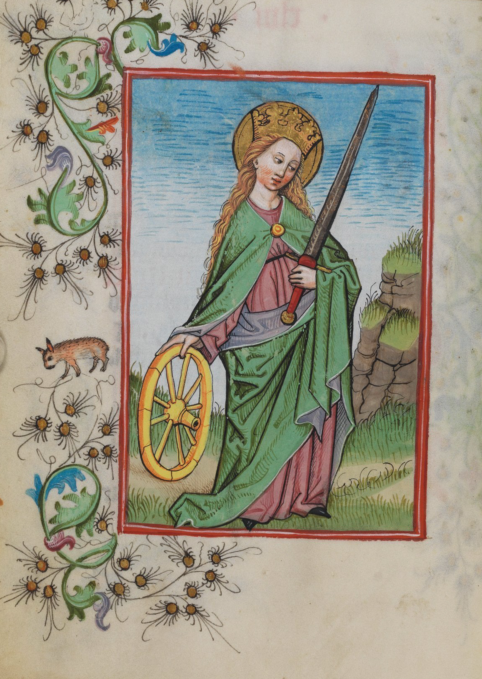
Fig. 1 St Catherine of Alexandria from Walburg-Gebetbuch ((Waldburg-Gebetbuch, WLB Stuttgart, Cod. brev. 12, fol. 47V ))

Panofsky’s third level is a hermeneutic meaning which requires what he terms iconographical interpretation. This takes into account the wider context within which the image is located to reveal attitudes of nation, period, class, religious or philosophical leanings (Panofsky, 1962, p. 7). This move from analysis to interpretation allows us, for instance, to draw inferences from Leonardo’s Last Supper about his personality, religious attitudes and Italian High Renaissance culture in general (Panofsky, 1962, p. 8). It also moves the discipline from iconography to iconology itself.
The techniques of the digital humanities have had some success in bringing Panofsky’s first, pre-iconographical, level into the digital world. Image recognition techniques are now well advanced and are quite capable of identifying the components of an image (their forms and their associated natural-world objects) with increasing accuracy: for instance, recent work on English broadside ballads (Stahmer, 2016; Chung et al., 2015) is producing impressive results. His third level, that of hermeneutic interpretation, will always be to a major extent the domain of the human scholar, aided often by the empirical evidence that the tools of digital humanties research can deliver.
It is Panofsky’s second level, that of the identification of iconographic subjects through the analysis of motifs and their combinations, that should be amenable to current methodologies in the digital humanities and is the subject of this article. This type of analysis concerns itself with the drawing of semantic linkages between the components of an image and using the semantic network that is built up by these to draw inferences as to its likely subject. As such, it has clear parallels with the network of semantics linkages that make up machine-readable ontologies encoded in the Web Ontology Language, OWL (World Wide Web Consortium W3C, 2012). This methodology offers a way to replicate some of the processes of iconographic analysis potentially to enable the automated identification of iconographic subjects.
Iconography and ontology: earlier approaches
Very little research has been carried out into the use of ontologies in iconographic studies. The only significant work in this field to date have been that of the Encyclopaedia of Bulgarian Iconography which has devised a simple tri-partite ontology covering identification (such features as the title, author period or iconographic school of an image), technical information (such as materials, varnish or gilding) and essential information on content and representation (such as depicted characters, symbols and canonical types) (Pavlov et al., 2010, p. 283). The third of these entities allows for the formal expression of such details of the characters or symbols as facial characteristics, gestures, clothing and objects that they hold (Paneva et al., 2008, p. 284).
Useful as it is as a method of formalizing the components of iconographic identification, this ontology is firmly rooted in Panofsky’s first level of pre-iconographical description. It provides a means of describing the components of an image and their mutual relations but not the contextual information necessary for Panofsky’s second level iconographic analysis. It is this level, which is a lacuna in the Bulgarian ontology, that the methodology discussed in the remainder of this article seeks to address.
OWL: the Web Ontology Language
This methodology employs OWL, the Web Ontology Language, as the primary mechanism for the encoding of a machine-readable ontology which attempts to replicate the processes of Panofsky’s iconographic analysis, particularly the clues or indicators used to identify subjects.
OWL is a well-established and interoperable format for the encoding of ontologies of this kind. Tom Gruber was one of the first to define ontologies in the context of information as “an explicit specification of a conceptualization” (Gruber, 1995), essentially a structure of knowledge within a given domain. OWL allows such a structure to be encoded in the form of classes of objects and the relationships between them, all in a non-application specific and interoperable format (such as OWL’s own XML syntax or RDF).
OWL ontologies draw on the components of formal logic to express axioms and allow logical inferences to be drawn which are not explicitly encoded. A property may be defined, for instance, to assert that person A is an ancestor of person B, and the same property applied to define person B as an ancestor of person C. Although it may not be explicitly recorded in such an ontology, a logical inference may be drawn that person A is an ancestor of person C if the ancestor property is properly defined (specifically that the property is transitive); such an inference may be derived automatically by employing a software application known as an inference engine. A basic introduction to OWL and its application of formal logic may be found in Horridge et al (2004).
It is in its ability to allow inferences to be drawn from its structures of semantic relationships defined with formal logic that OWL offers a viable medium for supporting iconographical analysis as defined by Panofsky. The methodology defined here attempts to represent, at least in embryonic form, the knowledge structures used in such an analysis in the form of the image components and their relative weights that enable the identification of an iconographic subject.

The components of an iconographic identification
The processes by which a subject is identified in iconographic analysis are best illustrated by an example of an image in which contextual information, the knowledge of the iconographic expert, would be needed to enable an identification to be made.
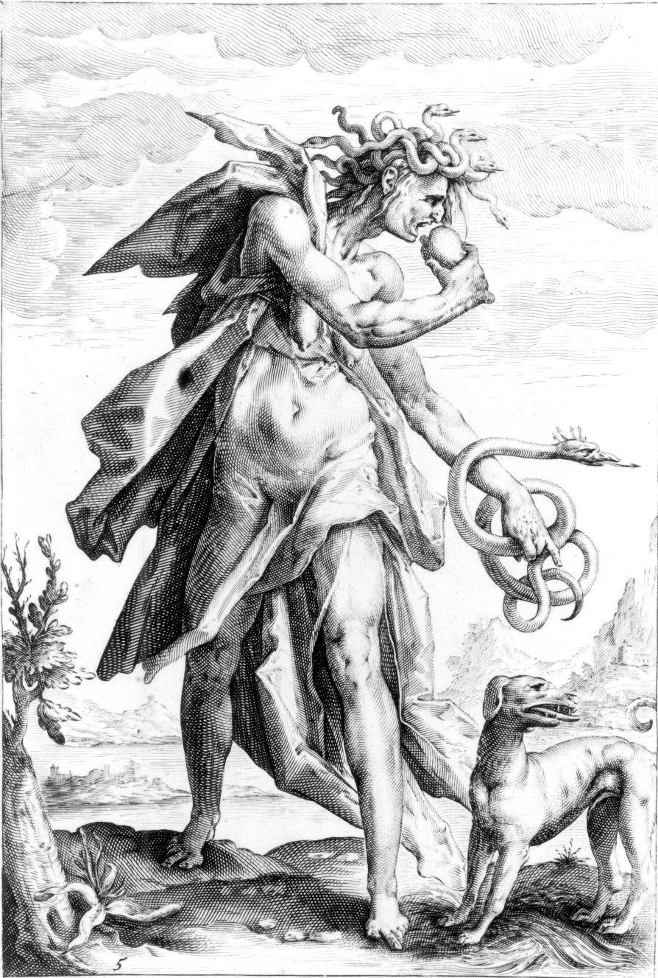
Fig. 2 Envy by Jacob Matham after designs by Henrick Goltzius (ca. 1587)

Figure 2 is an engraving dated ca. 1587 by the Dutch engraver Jacob Matham after designs by Henrick Goltzius: it depicts a personification of Envy, one of a series of personified vices in this series. To determine the iconographic subject of this engraving, the art historian will examine the image for a series of clues or pointers: in this case, these would include:-
- species: Envy is always a human
- gender: Envy is always represented as female
- actions: here Envy holds a snake: this is a clue to her identification but not a conclusive one – she is occasionally depicted in this way but not exclusively
- appearance: Envy here has a head of hair consisting of snakes: in the majority of post-medieval representations of this vice, she will have this feature, but, again, not exclusively – a significant number of representations of Envy omit this feature.

None of the clues is definitive, as is the case for most iconographic identifications: they can merely act as pointers towards a given subject. However, some are more definitive pointers to a given subject than others: the head of snakes is a relatively strong clue towards an identification of Envy, while her holding a snake is less so but still an indicator of a potential match. The fact that Envy is almost always depicted as female is a strong negative indicator for excluding any image depicting a male, but can offer little guidance beyond that.
Because very few features of an iconographic subject are definitive any representation of these pointers or clues in an ontology is necessarily limited to indicating some degree of the relative strengths that each might possess in aiding an identification. It may, for instance, give a high priority to gender in this case (but only to the extent of not excluding Envy as a possible match if the figure is female), a medium/high priority to a head of snakes, and a medium priority to a figure holding a snake.
Encoding these components in OWL
The first stage in defining an ontology for iconographic subjects is the identification of its classes, the sets of conceptual components which are combined by semantic linkages to express what Gruber calls a ‘conceptualization’. The first class to be defined are the discrete objects that may be identified within an image. These are termed unitary objects in the ontology: this class includes such broadly defined objects as animate figure or more specific ones such as jug or fruit. These are the features of an image which one would expect to be identified by image recognition software, the essential components from which an iconographic identification can be made.
The second class of objects, termed object parts in the ontology, are those which form constituent parts of the first class. This may include parts of the body (hair, hand, foot) or parts of an inanimate object (for example, the blade or shaft of a sword). In general, these are defined as components which do not possess a boundary surrounding them to separate them from the background of an image. They would tend, therefore, not to be identified as discrete components by image recognition techniques.
A further class is used to define features of these objects which may be important in identifying the iconographic subject of which they form a part. These object facets may include their gender, their lateral axis (left or right to distinguish cases where, for example, an object held in the left or right hand makes a difference to the identification of a subject) and species. A fourth class is used to define actions that one object may be performing on another (or unilaterally): this may include such sub-classes as holding and eating.
A final top-level class is used to indicate the relative weighting that should be given to a feature that could be considered a clue or indicator to an iconographic subject. These iconographic subject indicator strengths are at present a simple five-part range (low, low-medium, medium, medium-high and high): they may also have numerical values attached to enable weightings to be calculated if required.
Complementing the core classes in an ontology are a series of properties, assertions of semantic linkages which are used to join these together to create the ‘specification of a conceptualization’ defined in an ontology. As is the case with the classes above, these are divided into a small number of categories. The first relates objects to features which are relevant to enabling an iconographic identification: they include hasSpecies, hasGender, hasLateralAxis. Another, isComponentOf and its inverse hasComponent, relates parts of objects to their whole. A further small set relates an object to the actions that it performs: these include performsAction (which, for example, may indicate that the personification of Envy in Fig. 2 is performing the actions holding and eating), performativeActionObject (to indicate in this case what is being held and eaten) and performativeActionInstrument (to indicate here what is being used to hold an object being, namely Envy’s left hand).
To encode the clues or pointers to an iconographic identification, it is necessary to impose a series of restrictions on the class Envy which describe its key features. Because it is unlikely that a set of clues will be entirely sufficient to define a personification unambiguously, we cannot define what formal logic terms necessary and sufficient conditions for it: instead we can only designate a small number of necessary conditions and a further set which may not even be necessary but are merely potential indicators towards an identification. An iconographic subject can, therefore, only be what in OWL is termed a primitive class, one which has no more than necessary conditions attached to it, not the necessary and sufficient ones necessary to define it precisely.
The five ‘clues’ towards the identification of Envy listed above may be encoded in OWL in the following ways:-
Species and Gender
These are both necessary but not sufficient conditions for the identification. Envy must be a human figure and must be female, so excluding figures that do not meet these criteria, but they go no further than excluding non-humans and male figures from an identification as Envy.
These conditions are expressed in formal logic by defining a universal restriction, that is a requirement that their respective properties (here hasSpecies and hasGender) map to one value only (human and female respectively). Universal restrictions (also called AllValuesFrom restrictions) are denoted by the symbol ∀ and so the relevant restrictions here would be
∀ hasSpecies human
∀ hasGender female
Action: Holding a Snake
To define a clue or pointer to an iconographic identification that carries a certain weight is rather more complex: the clue itself must first be associated with the weight it carries and then itself be defined in terms of components from the ontology’s class hierarchy.
To define the weight for the clue, we first have to associate the class hasWeight with one of the values, high, medium-high, medium, low-medium or low: this can be done by defining a universal restriction as above:-
∀ hasWeight medium
If for the moment we call the action holdsSnake (this will be replaced later by a definition of what holding a snake actually is), we can then use the property hasIndicator to link the personification of Envy to this action. In this case, we impose what is known as an existential restriction, one that need not necessarily be limited to one value only (as an image may well have multiple indicators): this type, also known as a SomeValuesFrom restriction, is denoted by the symbol ∃:
∃ hasIndicator holdsSnake
To assign the medium weighing to this indicator, it must be joined to the restriction on hasWeight defined above – this is done by creating what is known as an intersection class by joining the indicator and its weight together using a Boolean and operator (designated by the symbol ∩):
∃ (hasIndicator (holdsSnake ∩ (∀ hasWeight medium)))
This statement shows that the indicator is the class of holding a snake which has a medium weighting (as opposed to those classes where holding a snake has a high or low weighting).
Now it is necessary to define more clearly what is meant by ‘holdsSnake’. This is an action (as opposed to other forms of indicators, such as features of appearance), and so will have the property performsAction to indicate this. The action itself has three features which indicate that it is one in which a snake is being held: first, the action itself (holding), secondly, the instrument with which this is done (a hand) and thirdly, unsurprisingly, the object which is being held (a snake). Two properties defined in the ontology, hasPerformativeActionInstrument and hasPerformativeActionObject, are used respectively to delineate these.
Each of the two features which define holdsSnake, the hand as instrument and the snake as object, are each defined by universal restrictions as hand and snake are the only values that their respective properties can hold: as both must be present, we create an intersection class of the two:
(∀ hasPerformativeActionInstrument hand) ∩ (∀ hasPerformativeActionObject snake)
These are then combined with the action holding into a further intersection class to form what we have previously referred to as holdsSnake:
holding ∩ (∀ hasPerformativeActionInstrument hand) ∩ (∀ hasPerformativeActionObject snake)
This as a whole is then linked to the property performsAction to clarify that this indicator is an action rather than a feature of appearance or some other form of clue: this is once more a universal restriction as only one which contains all of these elements may be considered holdsSnake:
∀performsAction (holding ∩ (∀ hasPerformativeActionInstrument hand) ∩ (∀ hasPerformativeActionObject snake))
Replacing holdsSnake with the rather complicated expansion of this property, gives us the full hasIndicator property, including its weighting:-
∃ (hasIndicator (∀performsAction (holding ∩ (∀ hasPerformativeActionInstrument hand) ∩ (∀ hasPerformativeActionObject snake)) ∩ (∀ hasWeight medium)))
We thus say that one (but not the only) indicator for a figure being Envy is that she is performing the action of holding a snake in her hand and that this indicator has a medium weighting.

Appearance: Snakes in Hair
As mentioned earlier, a head of hair composed of snakes is another indicator of Envy to which we might in this case wish to give a medium-high weighting. Here we use a further property hasComponent to indicate constituents that may carry some semantic meaning. We record that hair is composed of snakes by a further combination of a universal (only) restriction and an intersection:-
hair ∩ (∀ hasComponent snake)
We then indicate that this combination of hair and its constituent snakes is itself a component of the entire figure by embedding it as a universal restriction within a further hasComponent property:-
∀ hasComponent (hair ∩ (∀ hasComponent snake))
This statement is linked to its medium-high weighting by an intersection and the whole statement embedded as an existential restriction to hasIndicator (as was done to indicate the action of holding a snake):
∃ (hasIndicator (∀ hasComponent (hair ∩ (∀ hasComponent snake)) ∩ (∀ hasWeight medium-high) )

Figure 3 summarizes the indicators for this personification: -
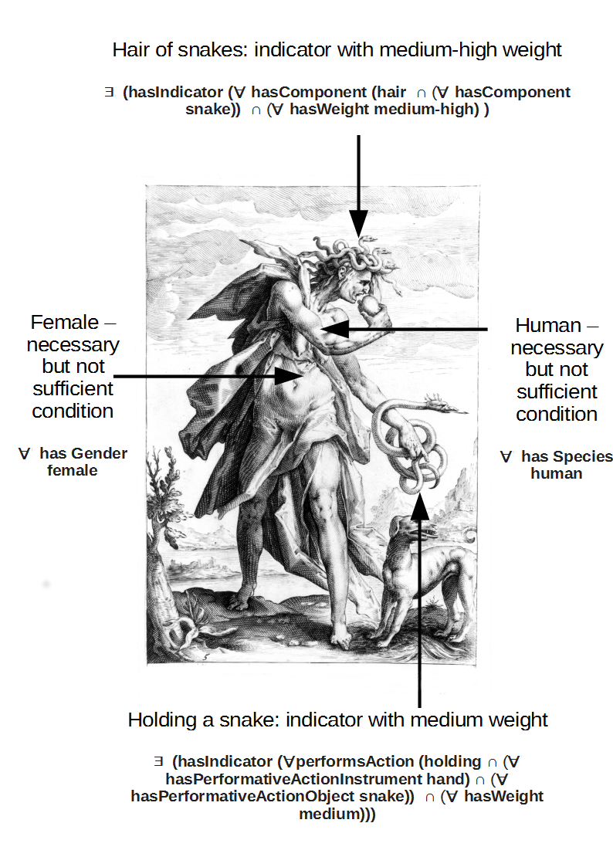
Fig. 3 Personification of Envy annotated with ontological properties for identification
Querying the Ontology
The purpose of encoding these indicators or clues to an iconographic subject is to enable their machine-readable identification. To do so requires some method for interrogating a corpus of ontological statements such as those recorded in this relatively simple example. We may wish in this case to search such a corpus for female, human figures with hair composed of snakes and holding a snake in order to retrieve possible personifications with these characteristics and to achieve some sense of their relative weights as identifiers for a given personification (in this case, Envy).
The most straightforward method to query the OWL-encoded ontology is to use standard methods for searching XML files to query it in this format. The statement of the indicator for envy of holding a snake (and it’s weighting of ‘medium’) is recorded in a relatively simple set of nested elements:-

<SubClassOf>
<Class IRI="#envy"/>
<ObjectIntersectionOf>
<ObjectSomeValuesFrom>
<ObjectProperty IRI="#hasIndicator"/>
<ObjectAllValuesFrom>
<ObjectProperty IRI="#performsAction"/>
<ObjectIntersectionOf>
<Class IRI="#holding"/>
<ObjectIntersectionOf>
<ObjectAllValuesFrom>
<ObjectProperty IRI="#hasPerformativeActionInstrument"/>
<Class IRI="#hand"/>
</ObjectAllValuesFrom>
<ObjectAllValuesFrom>
<ObjectProperty IRI="#hasPerformativeActionObject"/>
<Class IRI="#snake"/>
</ObjectAllValuesFrom>
</ObjectIntersectionOf>
</ObjectIntersectionOf>
</ObjectAllValuesFrom>
</ObjectSomeValuesFrom>
<ObjectAllValuesFrom>
<ObjectProperty IRI="#hasWeight"/>
<Class IRI="#Medium"/>
</ObjectAllValuesFrom>
</ObjectIntersectionOf>
</SubClassOf>

XML may be searched using a language known, not very imaginatively perhaps, as XQUERY. This language allows searches to be conducted that take into account the pathways of an XML structure, particularly the layers of hierarchy in an XML instance. If we wish, for instance, to interrogate this ontology to find figures holding a snake in a hand, we would carry out a search of the type shown in Fig. 4:-

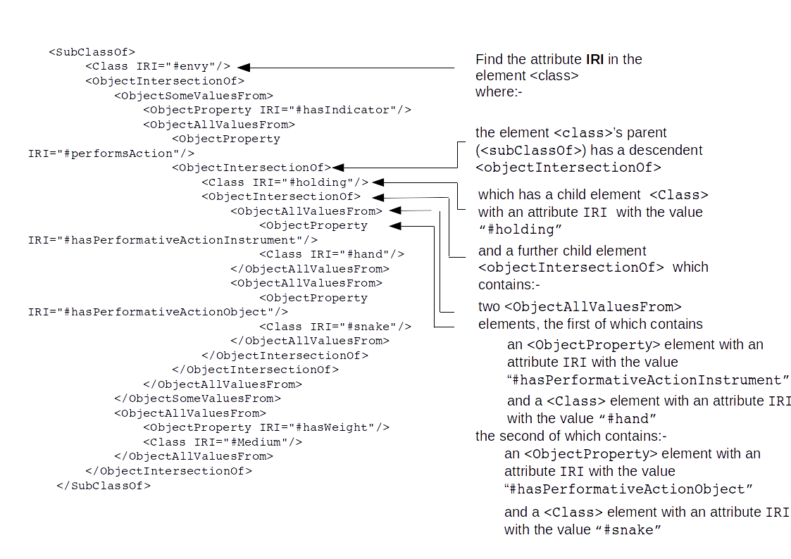
Fig. 4 Sample XQUERY query

This relatively complex set of search criteria can readily be expressed in a single XQUERY query:-
//SubClassOf[.//ObjectIntersectionOf[Class[@IRI='#holding'] and ObjectIntersectionOf[ObjectAllValuesFrom[ObjectProperty[@IRI='#hasPerformativeActionInstrument'] and Class[@IRI='#hand']] and ObjectAllValuesFrom[ObjectProperty[@IRI='#hasPerformativeActionObject'] and Class[@IRI='#snake']]]]]/Class/@IRI
This may then be readily modified to express the weighting attached to this indicator in the ontology:-
//SubClassOf[.//ObjectIntersectionOf[Class[@IRI='#holding'] and ObjectIntersectionOf[ObjectAllValuesFrom[ObjectProperty[@IRI='#hasPerformativeActionInstrument'] and Class[@IRI='#hand']] and ObjectAllValuesFrom[ObjectProperty[@IRI='#hasPerformativeActionObject'] and Class[@IRI='#snake']]]]]//ObjectAllValuesFrom[ObjectProperty[@IRI='#hasWeight']]/Class/@IRI
The terms ‘#holding’, ‘#hand’ and ‘#snake’ may, of course, be replaced by any other terms to search for items in which a different action is performed with a different instrument on a different object. Similar queries may be constructed for any other features of an image that may provide evidence for its iconographic identification.
Figures with hair of snakes can be found with the slightly simpler expression:-
//SubClassOf[.//ObjectIntersectionOf[Class[@IRI='#hair']][ObjectAllValuesFrom [ObjectProperty[@IRI='#hasComponent']] [Class[@IRI='#snake']]]]/Class/@IRI
and the respective weight of this indicator retrieved by a simple amendment to this statement:-
//SubClassOf[.//ObjectIntersectionOf[Class[@IRI='#hair']][ObjectAllValuesFrom [ObjectProperty[@IRI='#hasComponent']] [Class[@IRI='#snake']]]] //ObjectAllValuesFrom[ObjectProperty[@IRI='#hasWeight']]/Class/@IRI

Despite their apparent complexity, these search expressions are logical and relatively easily constructed. The iconographic ontology may, therefore, be readily searched in order to allow the knowledge base encapsulated within it to be interrogated in sophisticated ways. Encoding the ontology in an interoperable format such as OWL/XML also allows it to be shared and transmitted readily. But perhaps its potential will be most powerfully realized if it is combined with other techniques, most notably image recognition.

Future Directions
As noted above, image recognition technologies are now sufficiently advanced to enable the relatively sophisticated automation of Panofsky’s pre-iconographic description of an image, the recognition of its components and their mutual relations and placement; they are also effective at detecting expressive features, including poses and sentiments (such as mournful expressions). Current techniques do not, however, allow us to move to his second level of description, iconographic analysis or the identification of iconographic subjects.
An ontological description of iconographic subjects, such as is proposed here, will allow us to move to this level. An image recognition system could readily process the figure discussed throughout this article and identify her species, gender, her head of snakes and the fact that she is holding a snake in her hand. These results can then be used to construct an XQUERY search of an OWL ontology to identify possible matches for these criteria: the relative weighting attached to each clue or pointer can then be used to determine the relative probability of a successful identification having been made.
Because it is only rarely that an unequivocal identification can be made from a set of pointers, all that such an ontology-based system could realistically achieve is to present the user with a number of options from which to choose. Searching for female figures holding snakes, for instance, would also yield personifications of Prudence and Eternity in addition to Envy, requiring a final assessment of the subject to be done by human rather than machine. But it would be a powerful tool, nonetheless, allowing a much more rapid identification of iconographic subjects than is presently possible. The possibilities that this would open up for speeding up the cataloguing of image collections, for instance, would be considerable.
Conclusions
The application of machine-readable ontologies to the area of iconography clearly offers considerable potential to move the discipline further into the digital domain. It opens up the possibility of advancing it from Panofsky’s first level of iconographic analysis, the pre-iconographic, to the second, that of the identification of iconographic subjects. As should be evident from the above discussion, iconographic subjects can only rarely be identified unambiguously from a small number of clues and pointers: in the language of formal logic, it is rarely possible to declare an iconographic subject as a defined classed using necessary and sufficient conditions. These techniques can, therefore, at best be used to winnow down potential matches to a relatively small number for final judgement by a human interpreter.
This technique does, nonetheless, offer considerable potential to extend current techniques of image recognition into areas of semantic identification that are at present beyond their capabilities. The fluidity and flexibility of an OWL ontology allows for the sophisticated combination in a machine-readable context of the clues that an iconographic expert would deploy in the identification of subjects. As also noted, however, the limitations of formal logic as compared to the nuances and judgements of which a human interpreter is capable place their own limitations of what can be achieved here. We may envisage being able to submit a picture to an image recognition application and to be returned a set of potential iconographic subjects but rarely will the results be as unambiguous as that which can be achieved by asking a human expert.
Nonetheless, this would still be a very valuable resource, particularly if a large corpus of iconographic subjects and their identifying clues or pointers could be created. It would speed up the creation of iconographic databases considerably and could find potential applications in the museum and galleries sector in particular. While it would never render art historians redundant, it could prove a useful aid to their work. It may allow them, in particular, to shift their energies more from Panofsky’s second level of iconographic analysis to his third, that of interpretation, in which machine-readable analysis is unlikely to make much progress for the foreseeable future.
References

Chung, J.S., Arandjelović, R., Bergel, G., Franklin, A., Zisserman, A. (2015). Re-presentations of Art Collections, in: Agapito, L., Bronstein, M.M., Rother, C. (eds.), Computer Vision - ECCV 2014 Workshops. Champaign: Springer International Publishing, pp. 85–100.
Gruber, T.R. (1995). Toward principles for the design of ontologies used for knowledge sharing? International Journal of Human-Computer Studies, 43: 907–928.
Horridge, M. et al (2004). A practical guide to building OWL ontologies using the Protégé-OWL plugin and CO-ODE tools.
https://cse.buffalo.edu/faculty/shapiro/Courses/CSE663/Fall07/ProtegeOWLTutorial.pdf (accessed 9 January 2019).
Ionescu, V. (2012). Regarding the voice of images. A review of new perspectives in Iconology, visual studies and anthropology, Image and Narrative, 13: 177–180.
Paneva, D., Pavlova-Draganova, L., Draganov, L. (2008). Towards content-sensitive access to the artefacts of the Bulgarian iconography. International Journal of Information Technologies and Knowledge 2, 313–318.
Panofsky, E. (1962). Studies in iconology : humanistic themes in the art of the Renaissance. New York: Harper and Row,.
Pavlov, R., Paneva-Marinova, D., Goynov, M., Pavlova-Draganova, L. (2010). Services for content creation and presentation in an iconographical digital library. Serdica Journal of Computing, 4: 279–292.
Seebass, T. (2001) Iconography, Grove Music Online. http:////www.oxfordmusiconline.com/grovemusic/view/10.1093/gmo/9781561592630.001.0001/omo-9781561592630-e-0000013698 (accessed 10 April 2018).
Stahmer, C.G. (2016). Digital analytical bibliography: ballad sheet forensics, preservation, and the digital archive. Huntington Library Quarterly, 79: 263–278.
Urbina, E., Furuta, R., Smith, S.E., Audenaert, N., Deng, J., Monroy, C. (2006). Visual knowledge: textual iconography of the Quixote, a hypertextual archive, Literary and Linguistic Computing, 21: 247–258.
World Wide Web Consortium W3C. (2012). OWL Web Ontology Language Overview. http://www.w3.org/TR/owl-features/ (accessed 6 December 2012).

Acknowledgements

The authors acknowledges with thanks Dr Rembrandt Duits, Deputy Curator of the Photographic College, Warburg Institute, for his assistance in the compilation of this article.

